DAY - 3

Document Version: 1.0

Date: 28/01/2026

DAY: WEDNESDAY

Prepared By: Testing & Documentation Team

UI COMPONENTS TEAM:

MODULE 5: TIME TRACKING

Introduction:
Time tracking in UI components involves measuring the time users spend interacting with different interface elements. It helps analyze user behavior, evaluate performance, and improve the overall user experience.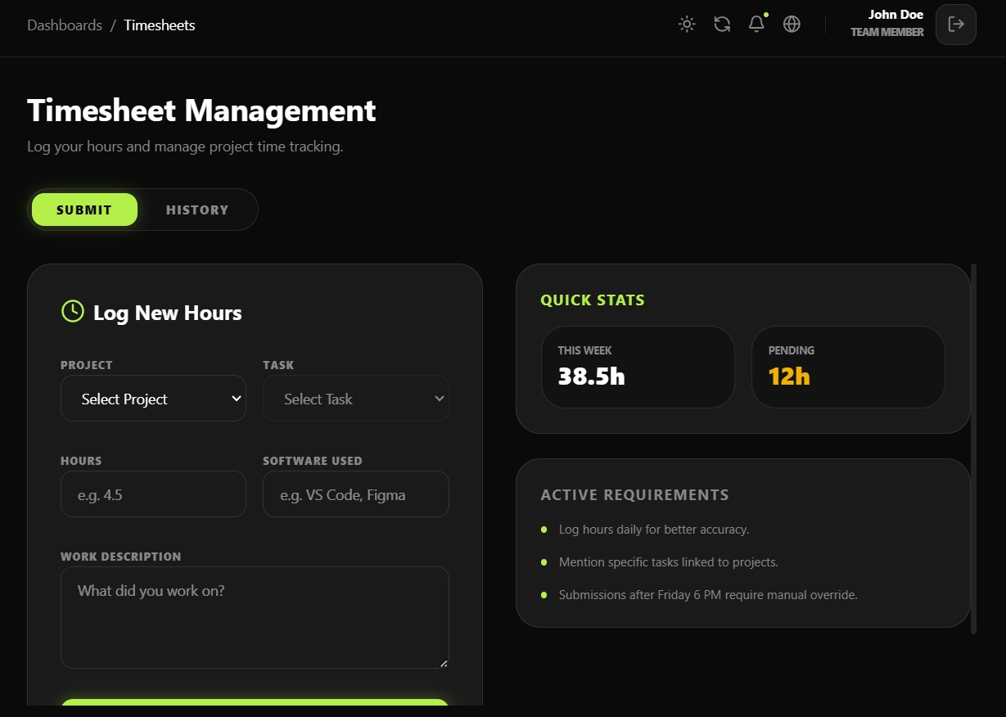
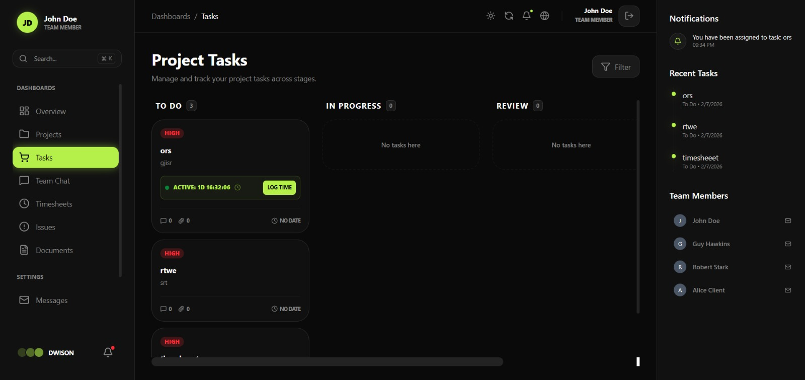

MODULE 6: COLLABRATION & COMMUNICATION

Introduction:
Collaboration and communication in UI components enable users to interact, share information, and work together within an application. These components support features such as messaging, notifications, shared views, and real-time updates, helping improve teamwork, coordination, and overall user engagement.
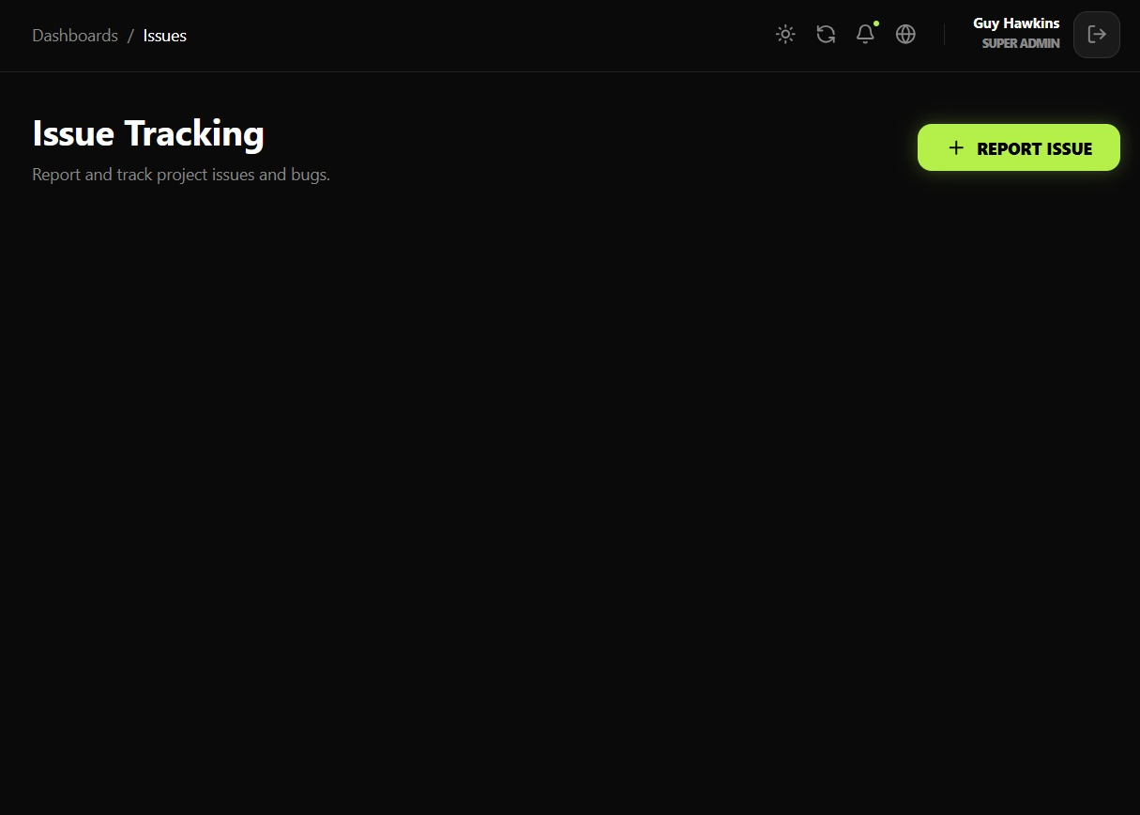

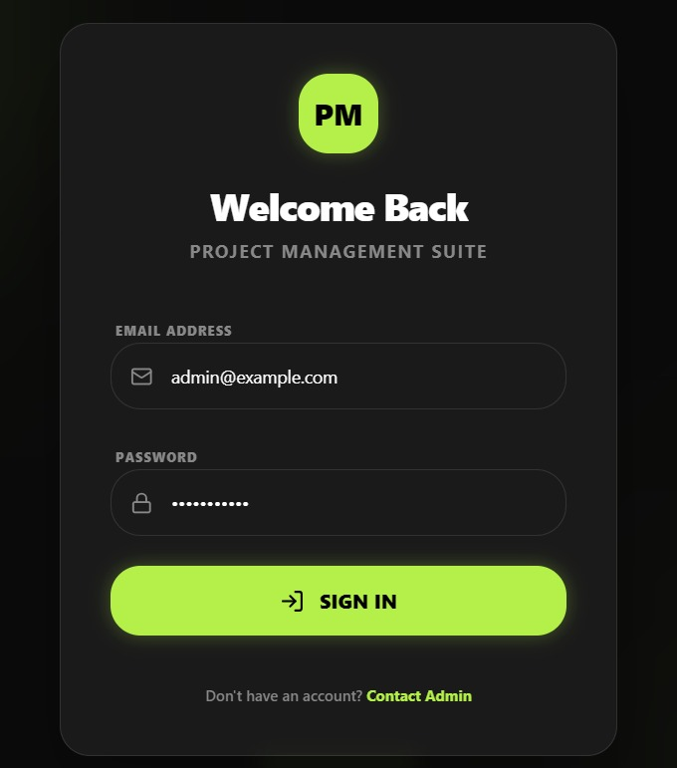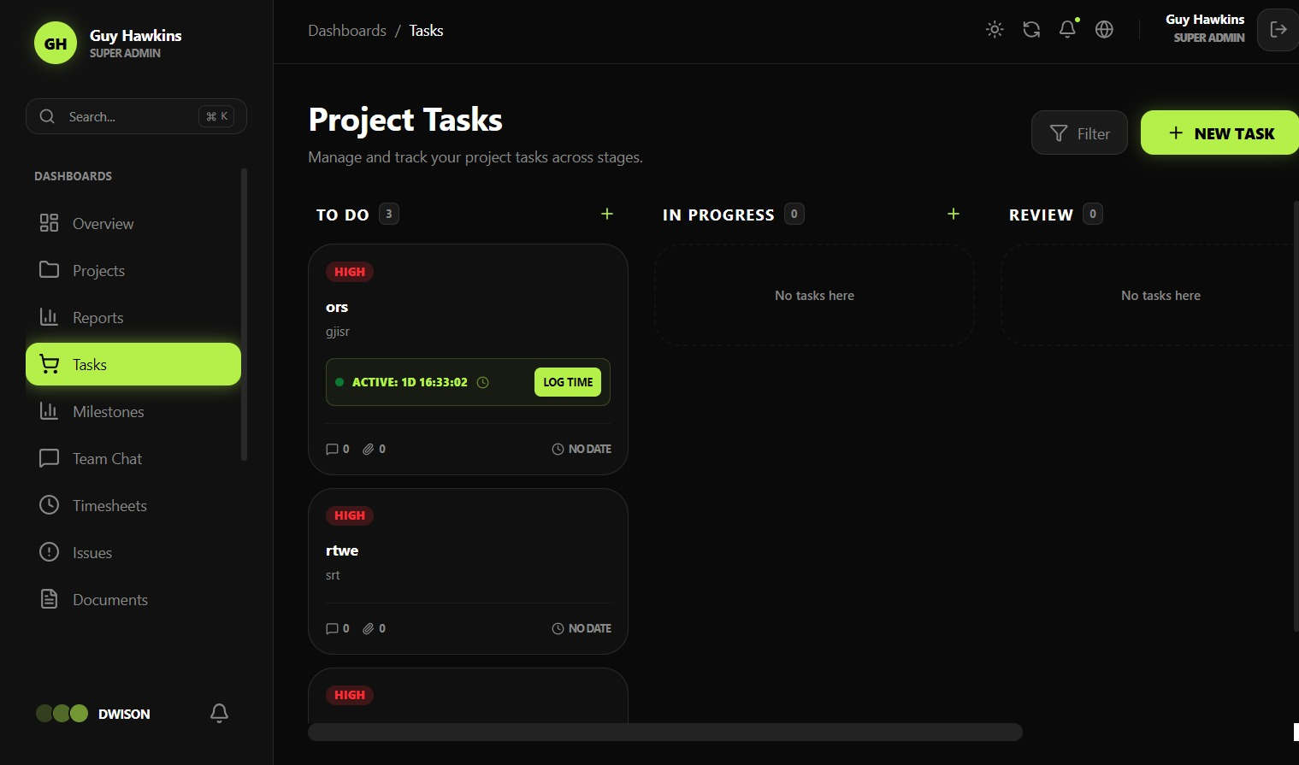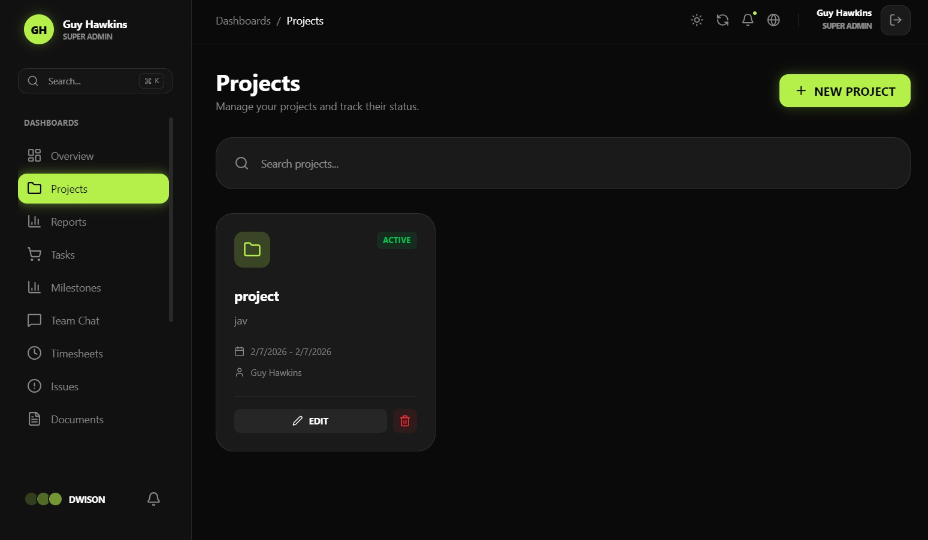

DASHBOARD DEVELOPMENT TEAM:

MODULE 2: PROJECT MANAGEMENT

Introduction:
Project management in dashboard development involves planning, organizing, and monitoring tasks to ensure the project is completed on time and meets requirements. The dashboard helps track progress, manage resources, and provide a clear overview of project activities.
SCREENSHOT: 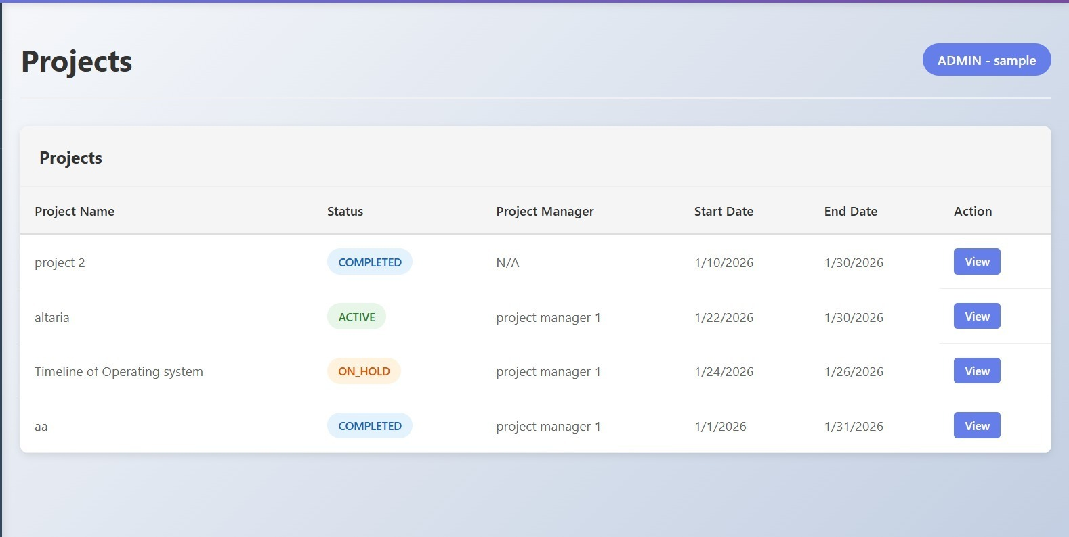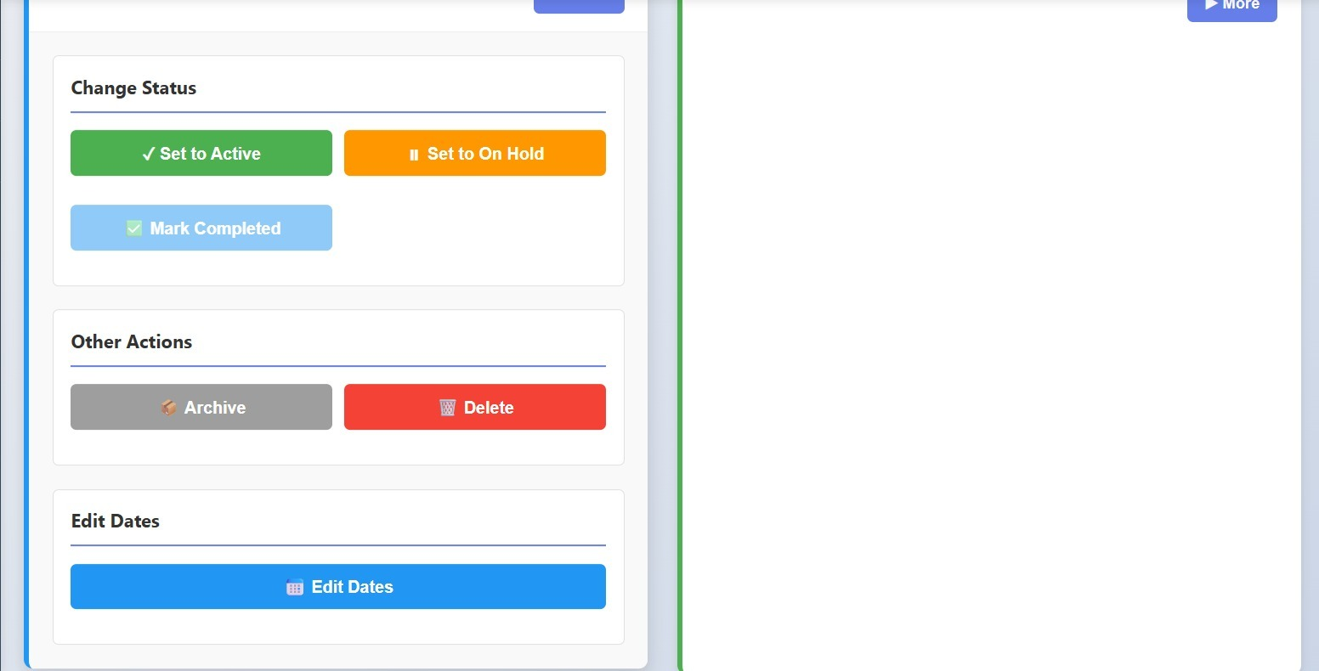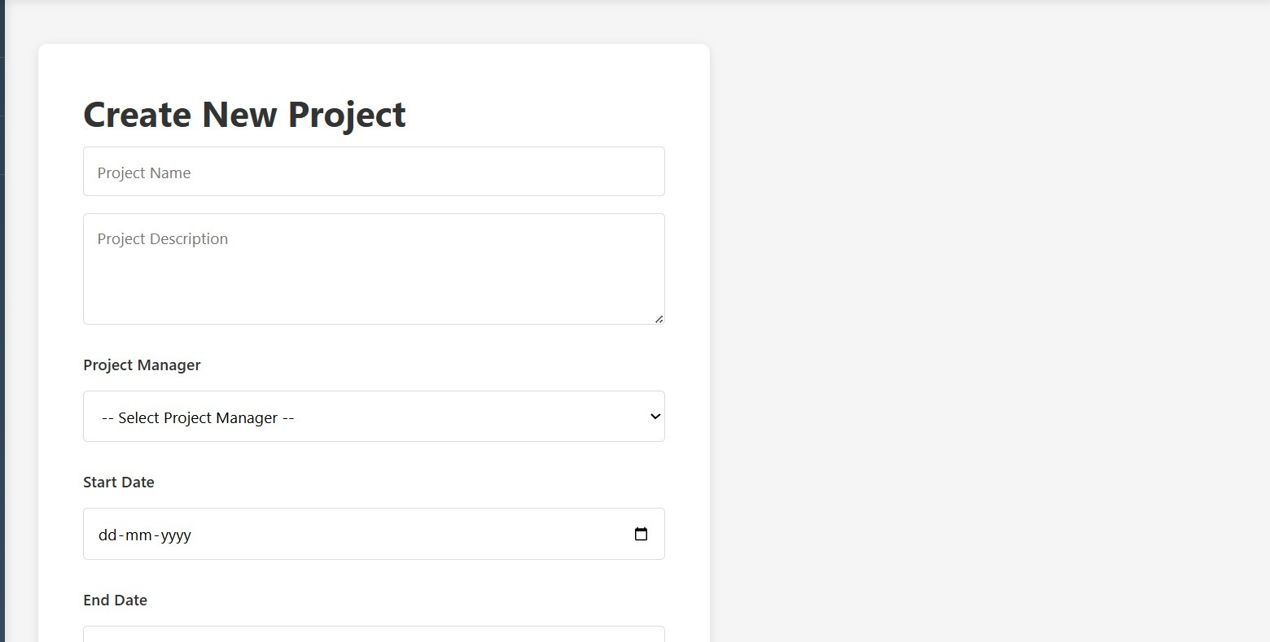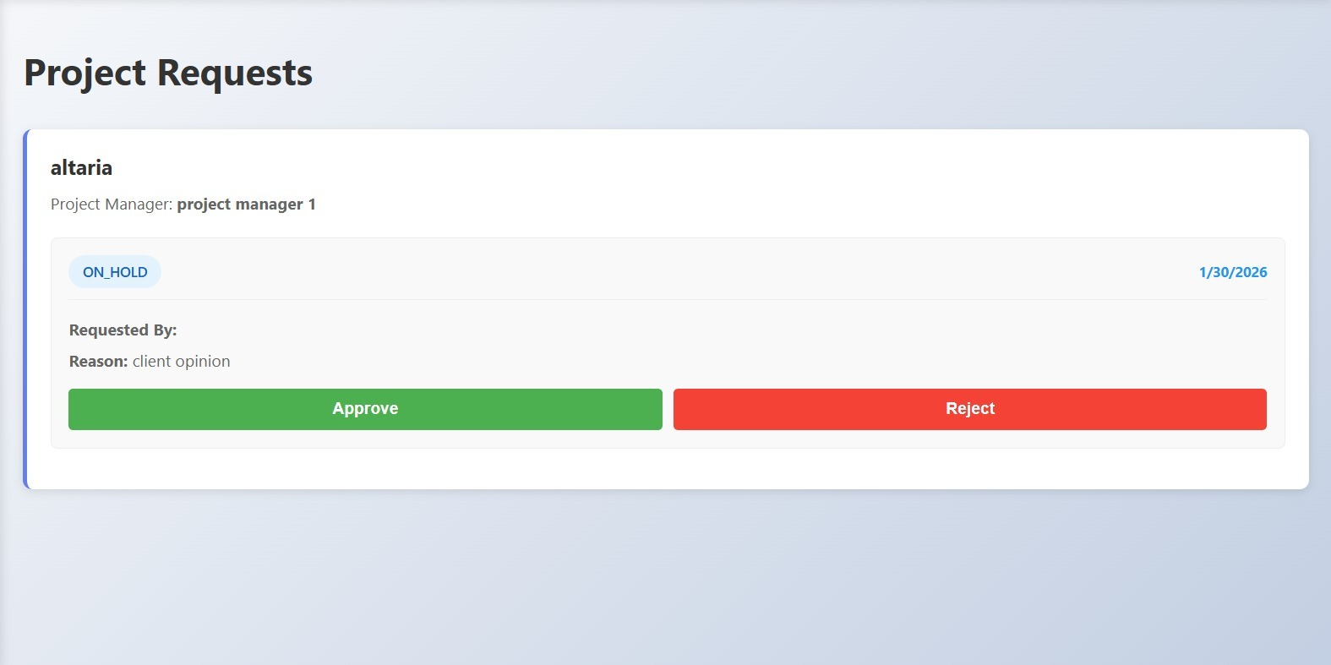
Description:
Admin Dashboard
An admin page was created to manage projects in the dashboard.
Admins can create new projects and assign them to project managers.
Admins can update project status, edit dates, archive or delete projects.
The system also allows admins to receive and review project requests from project managers.

MODULE 4: MILESTONE & PHASES

Introduction:
Milestones and phases in dashboard development represent key stages and important goals of the project. They help track progress, organize work, and ensure the project moves forward in a planned and structured manner.
SCREENSHOT: PENDING
Description: PENDING

TASK MANAGEMENT TEAM:

MODULE 7: ISSUE & BUG TRACKING:

Introduction:
Issue and bug tracking in task management involves identifying, recording, and resolving problems that occur during project execution. It helps teams monitor issues, assign responsibilities, and ensure timely fixes for smooth project progress.
SCREENSHOT: PENDING
Description: PENDING

MODULE 12: DASHBOARD VIEWS

Introduction:
Dashboard views in task management provide a clear and organized display of tasks, progress, and status updates. They help users quickly understand project information and manage work efficiently.

SCREENSHOT: 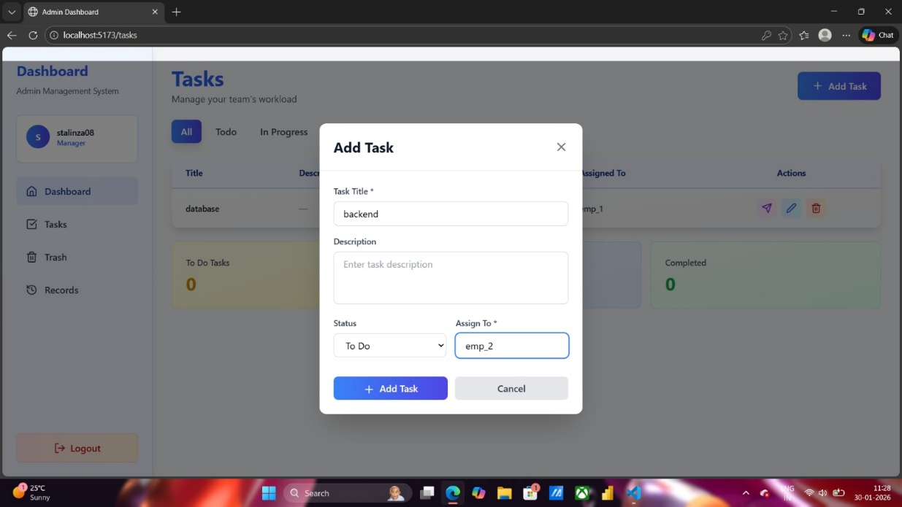
Description: Task Creation & Assignment
On Day 3, a backend development task was created and assigned to Employee 2. The task was added to the To-Do list, enabling proper tracking through the Task Management Dashboard.
Features:
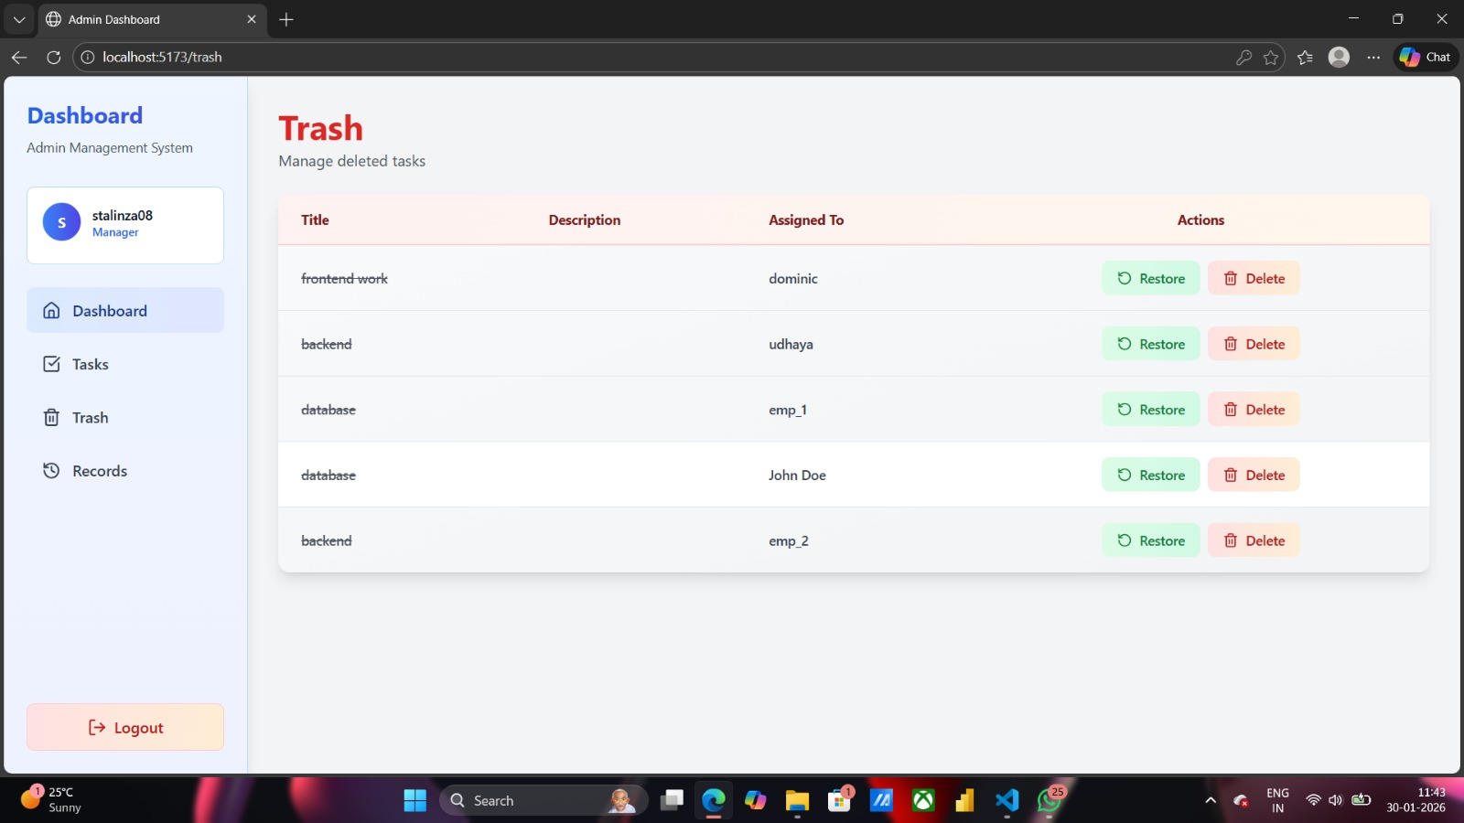
Trash/Bin
This panel shows the records about the tasks that are deleted and can be restored if the task assigned is needed

ANALYTICS & REPORT TEAM:

MODULE 9: REPORT & ANALYTICS:

Introduction:
Reports and analytics provide meaningful insights by collecting and analyzing project data. They help track performance, identify trends, and support better decision-making through clear visual and statistical information.
SCREENSHOT: PENDING
Description: PENDING

MODULE 10: NOTIFICATION & ALERTS

Introduction:
Notifications and alerts in analytics and reports inform users about important updates, changes, or critical events. They help ensure timely awareness and quick action based on data insights.
SCREENSHOT: PENDING
Description: PENDING

DESIGN & UX TEAM:

MODULE 1: AUTHENTICATION & ORGANIZATION:

Introduction:
Authentication and organization setup in design and UX ensure secure access and proper user management within the application. They help users sign in safely, define roles, and organize teams for a smooth and consistent user experience.

SCREENSHOT: 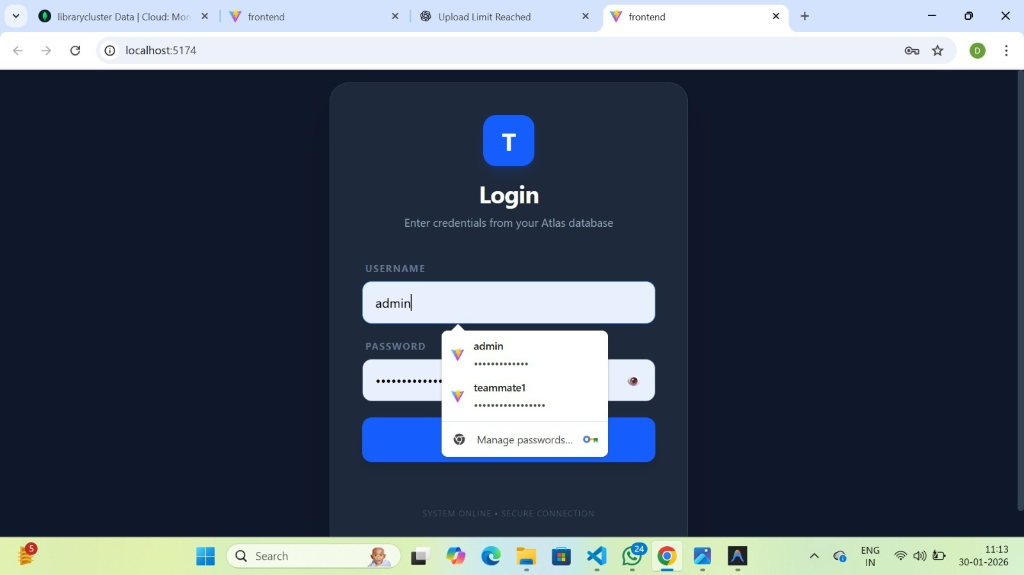
Description:
Improved the security of the authentication system by implementing password hashing. Integrated bcrypt in the Node.js and Express.js backend to hash user passwords before storing them in MongoDB Atlas. Updated the login process to compare hashed passwords during credential validation instead of plain text. This ensures better protection of user credentials and strengthens overall application security.

MODULE 10: TASK MANAGEMENT

Introduction:
Task management in design and UX focuses on organizing, assigning, and tracking tasks in a user-friendly manner. It helps users plan work efficiently and ensures a smooth and intuitive experience.
SCREENSHOT: 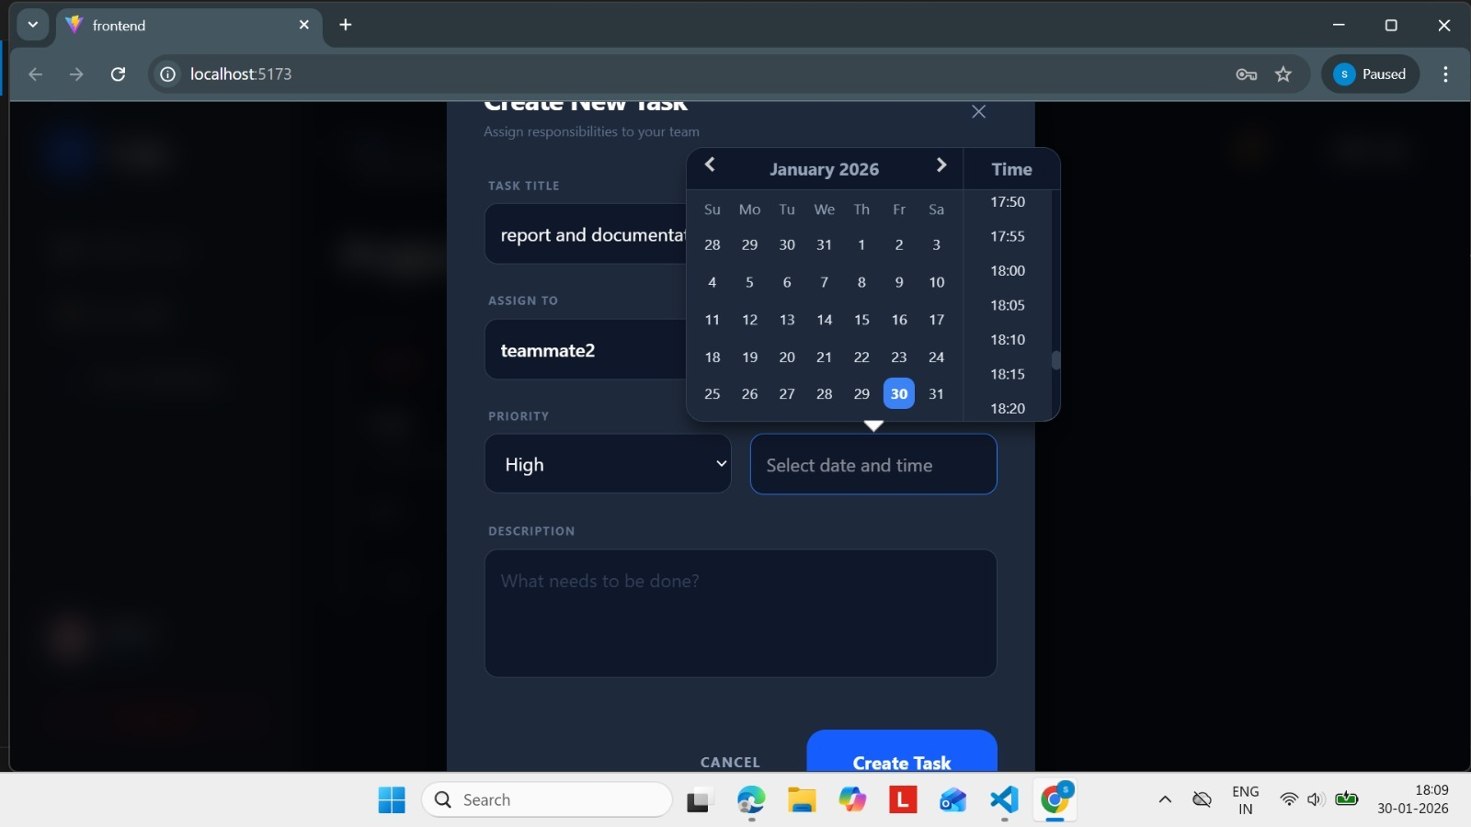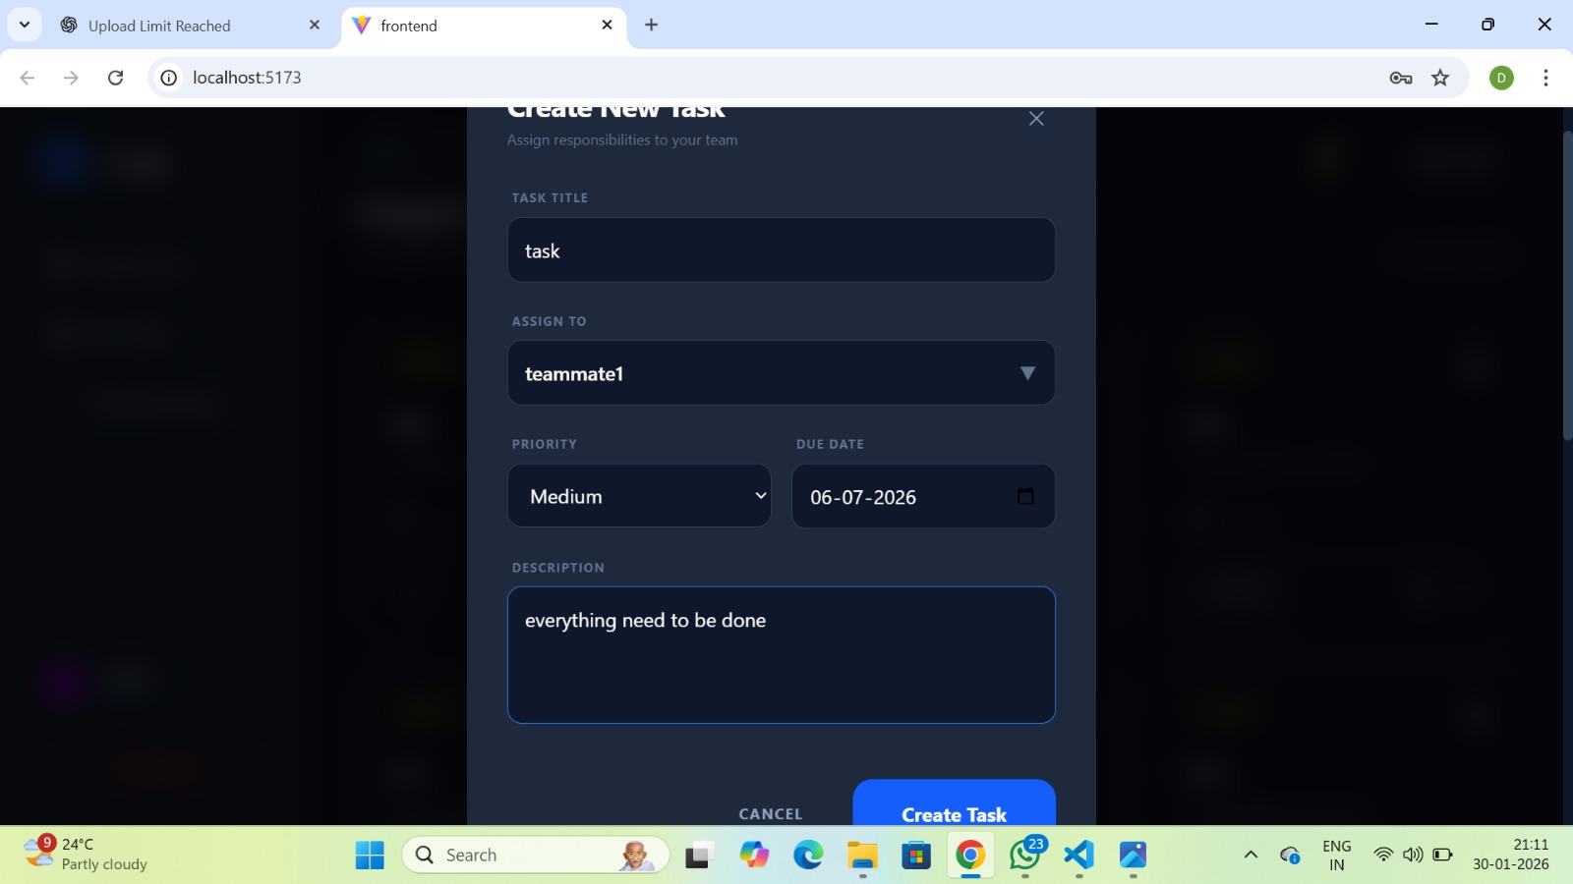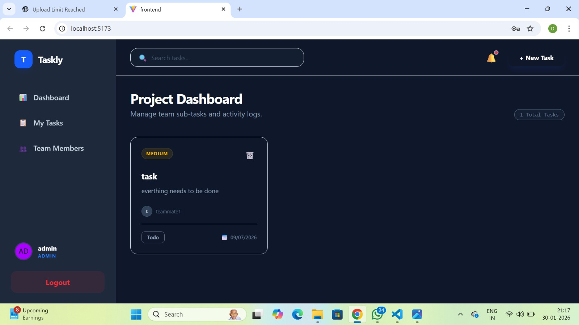
Description:
Enhanced the Task Management module by adding a calendar feature and enabling due date and time selection while creating tasks. Improved the description field to support detailed task input. Successfully completed the task creation flow, ensuring tasks are stored and then displayed on the dashboard for viewing. This allowed users to both create and track tasks in the system.

